Program Structures and Algorithms

Spring 2023(SEC – 1)

NAME: PAWAN KUMAR KRISHNAN

NUID: 002743773

**Task:**

Implement a parallel sorting algorithm such that each partition of the array is sorted in parallel. You will consider two different schemes for deciding whether to sort in parallel.

1. A cutoff (defaults to, say, 1000) which you will update according to the first argument in the command line when running. It's your job to experiment and come up with a good value for this cutoff. If there are fewer elements to sort than the cutoff, then you should use the system sort instead.
2. Recursion depth or the number of available threads. Using this determination, you might decide on an ideal number (*t*) of separate threads (stick to powers of 2) and arrange for that number of partitions to be parallelized (by preventing recursion after the depth of *lg t* is reached).
3. An appropriate combination of these.

**Relationship Conclusion:**

* As the number of threads Increase the amount of time taken to parallel sort is decreasing. This is happening across all array sizes( 1000000 to 9000000) in my case.
* The observed cutoff values are all around or below 20 percent of the arraysize.
* The optimal thread count and array size for minimizing completion time can vary depending on the specific task and cutoff. For example, when the cutoff is 160000 , the optimal thread count and array size are different than when the cutoff time is 320000 .
* As the array size increases, the min_time generally increases as well, indicating that the program takes longer to complete the task when working with larger arrays.
* The program's performance is highly dependent on the specific configuration used, including the number of threads, array size, and cutoff time. As a result, optimizing the program's performance requires careful experimentation and tuning of these parameters

**Evidence to support that conclusion:**

**The minimum time(miliseconds) to sort across all array size(1 to 9 million),threads(1,2,4,8(powers of 2)),cutoff (doubling 20000 onwards until less than array size)**

|  |  |  |  |  |
| --- | --- | --- | --- | --- |
| min_time | threads_min_time | min_array_ | cutoff% | cutoff |
| 319.5 | 1 | 1000000 | 16 | 160000 |
| 316.9 | 1 | 3000000 | 5.33333333 | 160000 |
| 318.6 | 1 | 5000000 | 1.6 | 80000 |
| 312.3 | 1 | 7000000 | 1.14285714 | 80000 |
| 315.1 | 1 | 9000000 | 1.77777778 | 160000 |
| 290.5 | 2 | 1000000 | 16 | 160000 |
| 306.5 | 2 | 3000000 | 2.66666667 | 80000 |
| 303.3 | 2 | 5000000 | 3.2 | 160000 |
| 292.2 | 2 | 7000000 | 2.28571429 | 160000 |
| 292.7 | 2 | 9000000 | 1.77777778 | 160000 |
| 292.1 | 4 | 3000000 | 5.33333333 | 160000 |
| 285.5 | 4 | 5000000 | 3.2 | 160000 |
| 281.1 | 4 | 7000000 | 2.28571429 | 160000 |
| 288.1 | 4 | 9000000 | 1.77777778 | 160000 |
| 269.3 | 8 | 3000000 | 10.6666667 | 320000 |
| 269.4 | 8 | 5000000 | 6.4 | 320000 |
| 274.1 | 8 | 7000000 | 18.2857143 | 1280000 |
| 255.4 | 8 | 9000000 | 14.2222222 | 1280000 |

**All the data observed across across all times (ms)**

|  |  |  |  |
| --- | --- | --- | --- |
| Arraysize | Threads | time in ms | cutoff |
| 1000000.00 | 1 | 454 | 20000 |
| 1000000.00 | 1 | 325 | 40000 |
| 1000000.00 | 1 | 337 | 80000 |
| 1000000.00 | 1 | 319 | 160000 |
| 1000000.00 | 1 | 351 | 320000 |
| 1000000.00 | 1 | 472 | 640000 |
|  |  |  |  |
| 3000000.00 | 1 | 345 | 20000 |
| 3000000.00 | 1 | 332 | 40000 |
| 3000000.00 | 1 | 317 | 80000 |
| 3000000.00 | 1 | 316 | 160000 |
| 3000000.00 | 1 | 361 | 320000 |
| 3000000.00 | 1 | 439 | 640000 |
| 3000000.00 | 1 | 545 | 1280000 |
|  |  |  |  |
| 5000000.00 | 1 | 345 | 20000 |
| 5000000.00 | 1 | 334 | 40000 |
| 5000000.00 | 1 | 318 | 80000 |
| 5000000.00 | 1 | 323 | 160000 |
| 5000000.00 | 1 | 400 | 320000 |
| 5000000.00 | 1 | 480 | 640000 |
| 5000000.00 | 1 | 567 | 1280000 |
| 5000000.00 | 1 | 734 | 2560000 |
|  |  |  |  |
| 7000000.00 | 1 | 353 | 20000 |
| 7000000.00 | 1 | 338 | 40000 |
| 7000000.00 | 1 | 312 | 80000 |
| 7000000.00 | 1 | 324 | 160000 |
| 7000000.00 | 1 | 360 | 320000 |
| 7000000.00 | 1 | 448 | 640000 |
| 7000000.00 | 1 | 578 | 1280000 |
| 7000000.00 | 1 | 776 | 2560000 |
| 7000000.00 | 1 | 771 | 5120000 |
|  |  |  |  |
| 9000000.00 | 1 | 330 | 20000 |
| 9000000.00 | 1 | 345 | 40000 |
| 9000000.00 | 1 | 315 | 80000 |
| 9000000.00 | 1 | 315 | 160000 |
| 9000000.00 | 1 | 367 | 320000 |
| 9000000.00 | 1 | 452 | 640000 |
| 9000000.00 | 1 | 589 | 1280000 |
| 9000000.00 | 1 | 680 | 2560000 |
| 9000000.00 | 1 | 778 | 5120000 |
|  |  |  |  |
|  |  |  |  |
| 1000000.00 | 2 | 424 | 20000 |
| 1000000.00 | 2 | 345 | 40000 |
| 1000000.00 | 2 | 297 | 80000 |
| 1000000.00 | 2 | 290 | 160000 |
| 1000000.00 | 2 | 316 | 320000 |
| 1000000.00 | 2 | 357 | 640000 |
|  |  |  |  |
| 3000000.00 | 2 | 342 | 20000 |
| 3000000.00 | 2 | 319 | 40000 |
| 3000000.00 | 2 | 306 | 80000 |
| 3000000.00 | 2 | 312 | 160000 |
| 3000000.00 | 2 | 315 | 320000 |
| 3000000.00 | 2 | 397 | 640000 |
| 3000000.00 | 2 | 458 | 1280000 |
|  |  |  |  |
| 5000000.00 | 2 | 331 | 20000 |
| 5000000.00 | 2 | 327 | 40000 |
| 5000000.00 | 2 | 310 | 80000 |
| 5000000.00 | 2 | 303 | 160000 |
| 5000000.00 | 2 | 311 | 320000 |
| 5000000.00 | 2 | 384 | 640000 |
| 5000000.00 | 2 | 420 | 1280000 |
| 5000000.00 | 2 | 488 | 2560000 |
|  |  |  |  |
| 7000000.00 | 2 | 341 | 20000 |
| 7000000.00 | 2 | 316 | 40000 |
| 7000000.00 | 2 | 301 | 80000 |
| 7000000.00 | 2 | 292 | 160000 |
| 7000000.00 | 2 | 308 | 320000 |
| 7000000.00 | 2 | 380 | 640000 |
| 7000000.00 | 2 | 406 | 1280000 |
| 7000000.00 | 2 | 456 | 2560000 |
| 7000000.00 | 2 | 435 | 5120000 |
|  |  |  |  |
| 9000000.00 | 2 | 327 | 20000 |
| 9000000.00 | 2 | 321 | 40000 |
| 9000000.00 | 2 | 302 | 80000 |
| 9000000.00 | 2 | 292 | 160000 |
| 9000000.00 | 2 | 318 | 320000 |
| 9000000.00 | 2 | 381 | 640000 |
| 9000000.00 | 2 | 426 | 1280000 |
| 9000000.00 | 2 | 507 | 2560000 |
| 9000000.00 | 2 | 449 | 5120000 |
|  |  |  |  |
|  |  |  |  |
| 1000000.00 | 4 | 353 | 20000 |
| 1000000.00 | 4 | 310 | 40000 |
| 1000000.00 | 4 | 317 | 80000 |
| 1000000.00 | 4 | 296 | 160000 |
| 1000000.00 | 4 | 290 | 320000 |
| 1000000.00 | 4 | 328 | 640000 |
|  |  |  |  |
| 3000000.00 | 4 | 355 | 20000 |
| 3000000.00 | 4 | 353 | 40000 |
| 3000000.00 | 4 | 304 | 80000 |
| 3000000.00 | 4 | 292 | 160000 |
| 3000000.00 | 4 | 299 | 320000 |
| 3000000.00 | 4 | 335 | 640000 |
| 3000000.00 | 4 | 377 | 1280000 |
| 3000000.00 | 4 | 334 | 2560000 |
|  |  |  |  |
| 5000000.00 | 4 | 306 | 20000 |
| 5000000.00 | 4 | 300 | 40000 |
| 5000000.00 | 4 | 290 | 80000 |
| 5000000.00 | 4 | 285 | 160000 |
| 5000000.00 | 4 | 288 | 320000 |
| 5000000.00 | 4 | 319 | 640000 |
| 5000000.00 | 4 | 343 | 1280000 |
| 5000000.00 | 4 | 336 | 2560000 |
|  |  |  |  |
| 7000000.00 | 4 | 347 | 20000 |
| 7000000.00 | 4 | 317 | 40000 |
| 7000000.00 | 4 | 294 | 80000 |
| 7000000.00 | 4 | 281 | 160000 |
| 7000000.00 | 4 | 283 | 320000 |
| 7000000.00 | 4 | 311 | 640000 |
| 7000000.00 | 4 | 341 | 1280000 |
| 7000000.00 | 4 | 303 | 2560000 |
| 7000000.00 | 4 | 437 | 5120000 |
|  |  |  |  |
| 9000000.00 | 4 | 309 | 20000 |
| 9000000.00 | 4 | 313 | 40000 |
| 9000000.00 | 4 | 301 | 80000 |
| 9000000.00 | 4 | 288 | 160000 |
| 9000000.00 | 4 | 315 | 320000 |
| 9000000.00 | 4 | 344 | 640000 |
| 9000000.00 | 4 | 329 | 1280000 |
| 9000000.00 | 4 | 304 | 2560000 |
| 9000000.00 | 4 | 449 | 5120000 |
|  |  |  |  |
|  |  |  |  |
| 1000000.00 | 8 | 349 | 20000 |
| 1000000.00 | 8 | 316 | 40000 |
| 1000000.00 | 8 | 293 | 80000 |
| 1000000.00 | 8 | 280 | 160000 |
| 1000000.00 | 8 | 269 | 320000 |
| 1000000.00 | 8 | 291 | 640000 |
|  |  |  |  |
| 3000000.00 | 8 | 333 | 20000 |
| 3000000.00 | 8 | 322 | 40000 |
| 3000000.00 | 8 | 291 | 80000 |
| 3000000.00 | 8 | 284 | 160000 |
| 3000000.00 | 8 | 269 | 320000 |
| 3000000.00 | 8 | 288 | 640000 |
| 3000000.00 | 8 | 282 | 1280000 |
|  |  |  |  |
| 5000000.00 | 8 | 339 | 20000 |
| 5000000.00 | 8 | 310 | 40000 |
| 5000000.00 | 8 | 296 | 80000 |
| 5000000.00 | 8 | 277 | 160000 |
| 5000000.00 | 8 | 269 | 320000 |
| 5000000.00 | 8 | 280 | 640000 |
| 5000000.00 | 8 | 273 | 1280000 |
| 5000000.00 | 8 | 336 | 2560000 |
|  |  |  |  |
| 7000000.00 | 8 | 331 | 20000 |
| 7000000.00 | 8 | 318 | 40000 |
| 7000000.00 | 8 | 291 | 80000 |
| 7000000.00 | 8 | 278 | 160000 |
| 7000000.00 | 8 | 276 | 320000 |
| 7000000.00 | 8 | 294 | 640000 |
| 7000000.00 | 8 | 274 | 1280000 |
| 7000000.00 | 8 | 328 | 2560000 |
| 7000000.00 | 8 | 436 | 5120000 |
|  |  |  |  |
| 9000000.00 | 8 | 341 | 20000 |
| 9000000.00 | 8 | 318 | 40000 |
| 9000000.00 | 8 | 283 | 80000 |
| 9000000.00 | 8 | 278 | 160000 |
| 9000000.00 | 8 | 274 | 320000 |
| 9000000.00 | 8 | 287 | 640000 |
| 9000000.00 | 8 | 255 | 1280000 |
| 9000000.00 | 8 | 324 | 2560000 |
| 9000000.00 | 8 | 452 | 5120000 |

**Cutoff % vs Array size across 1,2,4,and 8 threads**

The percentages do not seems to cross 20%. So less than 20% is the cutoff margin.

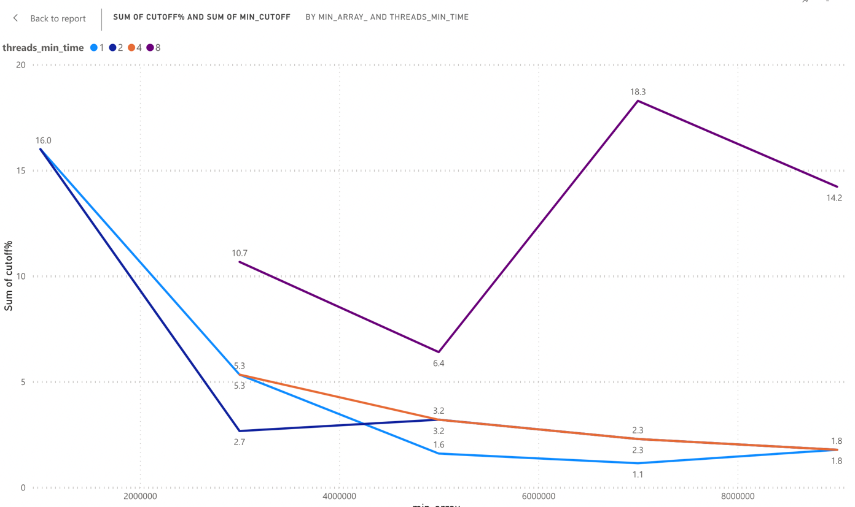

**time in miliseconds vs Array size across 1,2,4,and 8 threads**

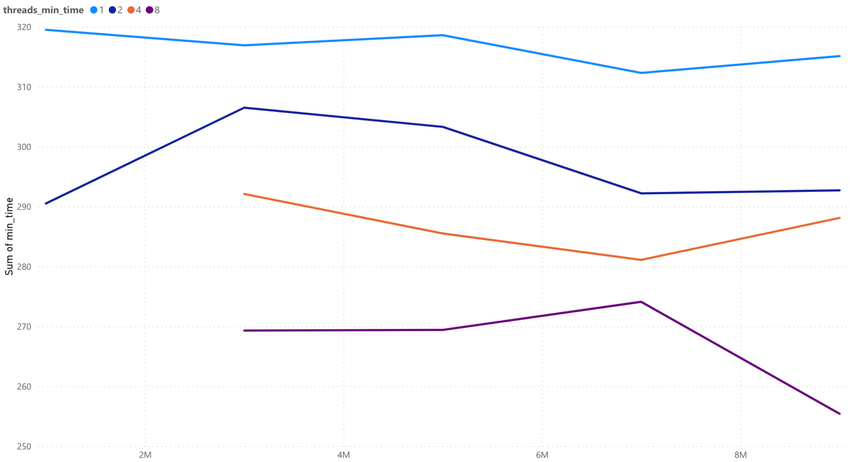

**Unit Test Screenshots:**

**NIL for this assignment**